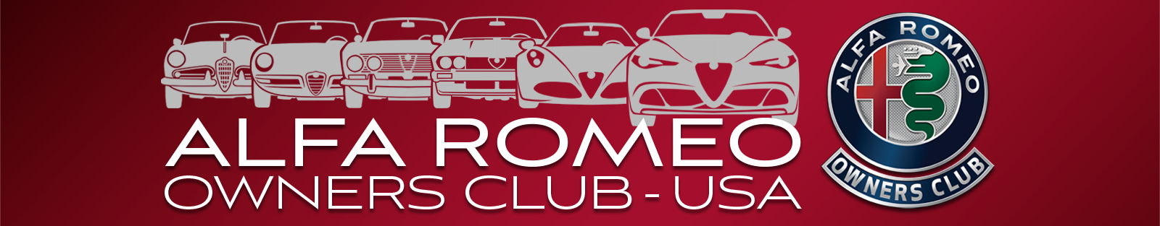

AROC-US Membership Application
You are invited to join the Alfa Romeo Owners Club, USA. With local chapters across America, your membership offers you a great opportunity to have fun with your car and meet some great people who share your enthusiasm for the Alfa Romeo marque.
------------------MEMBERSHIP BENEFITS------------------
Full Color Monthly Magazine – Technical Advice
Technical Library for all Models – National Convention
Meetings, Social Events and Tours
Alfa Romeo Tech Sessions – Rallies and Autocross Events
Yes! I want to join the fun. National Membership dues are $68 for a Standard 1-year membership which includes membership in one chapter* Pay by check, credit card or use the QR code below.

Name_____________________________________________________________________

Address___________________________________________________________________

City & State________________________________________________________________

Zip Code_________________________ Country__________________________________

Phone #_________________________Email _____________________________________

Chapter*___________________________________________________________________

Check Make check payable to AROC-USA

Credit Card: Visa MC AMEX Discover

Credit Card #_______________________________________________________________

Expiration Date______________________________ Code ______

Signature__________________________________________________________________

Join online at aroc-usa.clubexpress.com or send this application to
AROC Membership Director
AROC-USA * PO Box 92155 * Portland, OR 97292 *
call 971-254-6660; use the QR code to the right
****************** AROC-USA.CLUBEXPRESS.COM *******************

Please see our website for chapter locations and enhanced membership options.
*Some chapters have a local fee.

